# ARTIFICIAL INTELLIGENCE

**AI-BASED DISCOURSE FOR BANKING INDUSTRY PROJECT REPORT**

# TEAM LEAD: Sananda Shree T.R -190801143 TEAM MEMBERS

**Nivetha E -190801110**

# Priya V -190801123

**Santhya M.P -190801150 Of**

# BACHELOR OF ENGINEERING IN

**RAJALAKSHMI ENGINEERING COLLEGE (AUTONOMOUS )**

# AFFILIATED WITH ANNA UNIVERSITY

**CONTENTS**

## INTRODUCTION

* 1. Project Overview
  2. Purpose

## LITERATURE SURVEY

* 1. Existing problem
  2. References
  3. Problem Statement Definition

## IDEATION & PROPOSED SOLUTION

* 1. Empathy Map Canvas
  2. Ideation & Brainstorming
  3. Proposed Solution
  4. Problem Solution fit

## REQUIREMENT ANALYSIS

* 1. Functional requirement
  2. Non-Functional requirements

## PROJECT DESIGN

* 1. Data Flow Diagrams
  2. Solution & Technical Architecture
  3. User Stories

## PROJECT PLANNING & SCHEDULING

* 1. Sprint Planning & Estimation
  2. Sprint Delivery Schedule

1. **CODING & SOLUTIONING**
   1. Feature 1
   2. Feature 2

## TESTING

* 1. Test Cases
  2. User Acceptance Testing

## RESULTS

* 1. Performance Metrics

## ADVANTAGES & DISADVANTAGES

1. **CONCLUSION**

## FUTURE SCOPE

1. **APPENDIX**

Source Code

GitHub & Project Demo Link

# INTRODUCTION

## PROJECT OVERVIEW

In this project, we will be building a chatbot using Watson's assistant that helps banks for automating business processes such as customer service.

This chat should have the following capabilities:

* + - The Bot should be able to guide a customer to create a bank account.
    - The Bot should be able to answer loan queries.
    - The Bot should be able to answer general banking queries.
    - The Bot should be able to answer queries regarding net banking.

## PURPOSE

AI is particularly helpful in corporate finance as it can better predict and assess loan risks. For companies looking to increase their value, AI technologies such as machine learning can help to improve loan underwriting and reduce financial risk, AI-based systems can help banks reduce costs by increasing productivity and making decisions based on information unfathomable to a human agent. Also, intelligent algorithms are able to spot fraudulent information in a matter of seconds.

# LITERATURE SURVEY

## EXISTING PROBLEM

Most people see banks as these big, non-human entities that do not care about The individual problems of their customers. While the staff at local bank branches might still know most regular customers by name and provide personalized services, doing so via online and mobile banking is the main challenge. One of the biggest customer service challenges for banks is when their service executives are not able to resolve a problem, at least, not instantly. Unlike most B2C businesses, customer problems in banking are not always simple. They may face a broad range of problems, which include both simple and complex ones. Customer service executives are often loaded with too many requests and they fail to provide the required attention to each customer. This often leads to bad experiences and may even cause them to leave.

## REFERENCES

***PAPER 1 :***

**AUTHOR:** Mehmet Ates

**YEAR:** August 2017

**TITLE:** Artificial Intelligence in Banking

**METHODOLOGY:** This is a case study about the introduction of a virtual assistant into customer service. The research is based on a case study of the Swedish banking institute Swedbank AB, which introduced an AI-based virtual assistant (Nina) to deal with customer requests.

***PAPER 2 :***

**AUTHOR:** Vinod Kumar Shukla, Sasha Fathima Suhel, Sonali Vyas, Ved Prakash Mishra

**YEAR:** June 2020

**TITLE:** Conversation to Automation in Banking Through Chatbot Using Artificial Machine Intelligence Language

**METHODOLOGY:** This paper discusses some of the latest AI patterns and activities. System Chatbots are made. In the banking industry, the introduction of Artificial Intelligence has driven chatbots and changed the face of the interaction between banks and customers.

***PAPER 3 :***

**AUTHOR:** Shashank Bairy R, Rashmi R

**YEAR:** June 2021

**TITLE:** A Review of Chatbots in the Banking Sector

**METHODOLOGY:** Chatbot is a software application that listens to a user's query in natural language and responds accordingly. Answering customer queries and assisting customers with banking transactions are some of the ways in which it’s making an impact on the industry. This paper discusses the anatomy of chatbots and their applications in the banking sector. Improvements to current chatbot technologies are also suggested.

***PAPER 4 :***

**AUTHOR:** Dr. Shalini Sayiwal

**YEAR:** June 2020

**TITLE:** CHATBOTS IN BANKING INDUSTRY: A CASE STUDY

**METHODOLOGY:** Chatbots designed with AI are one of the most promising strategies of a banking business that can lead the bank to win the satisfaction vote of their loyal customers. Conversational Banking is a smarter way to retain loyal customers by offering them a quick response to their queries.

***PAPER 5 :***

**AUTHOR:** S Saleem

**YEAR:** 2020

**TITLE:** Application of Artificial Intelligence in Banking: A study based on SBI- SIA Virtual Assistant

**METHODOLOGY:** AI is supporting Indian banks in upgrading their operations across the board, from accounting to sales to contracts and cybersecurity. This is a case study based on the virtual assistant of SBI-SIA. Recent developments and the emergence of virtual banking and the trends in modern banking systems are explained in this study.

## PROBLEM STATEMENT DEFINITION

Our Chatbot allows users to make quick hassle-free query solving in a few seconds with top-notch security and data protection. With a chatbot, we can handle all of the simple customer requests, you could take the load off your employees. This, in turn, will provide your employees the time to tackle more complex queries. This will freeup some time for your customer care executives.

# IDEATION & PROPOSED SOLUTION

## EMPATHY MAP CANVAS

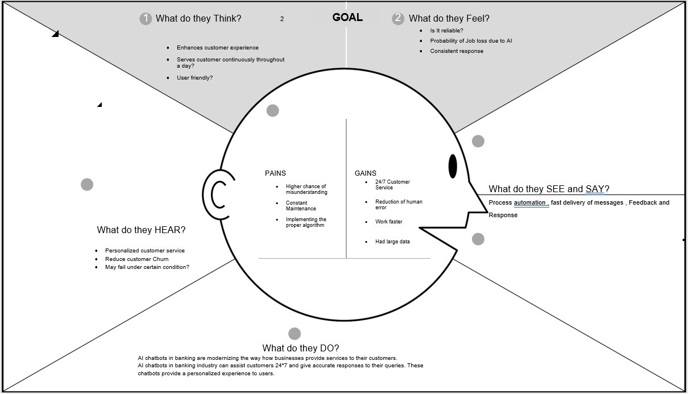

* 1. **IDEATION & BRAINSTORMING**

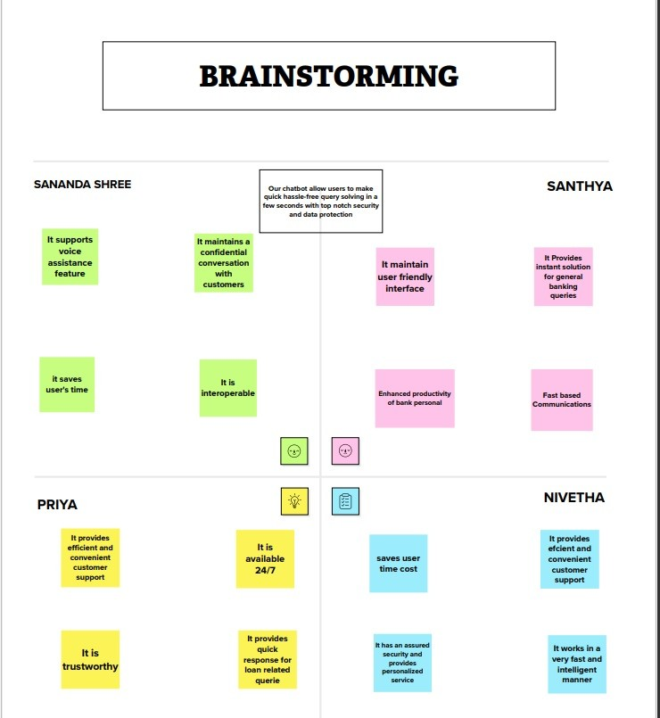

## PROPOSED SOLUTION

|  |  |  |
| --- | --- | --- |
| **S No.** | **PARAMETER** | **DESCRIPTION** |
| 1. | Problem Statement (Problem to be solved) | Our Chatbot allows users to make quick hassle-free query solving in a few seconds with top-notch security and data protection. |
| 2. | Idea/Solution Description | A bank chatbot is an AI- enabled conversational interface to interact with customers and provide help. This is done with the help of  :   1. Artificial intelligence 2. Watson Assistant 3. Cloud DB 4. Neural Network 5. NLP |
| 3. | Novelty/Uniqueness | AI-powered chatbots in banking are incredibly powerful and can manage smart communications on behalf of the bank saving time for both staff and customers. With a banking bot, it’s possible to handle many users simultaneously and enhance their experience. |
| 4. | Social Impact/ Customer Satisfaction | * Makes it possible to quickly get needed answers to questions * Helps to solve easy problems or complaints right away * Provides a more comprehensive answer to a specific query * Makes it possible to contact a human customer service specialist if needed. * Chatbots are used they want to |

|  |  |  |
| --- | --- | --- |
|  |  | streamline their operation and aren’t open 24/7. With robust chatbots, users can still acquire needed information even when your office is closed.   * Engage potential customers.   Chatbots allow you to engage website visitors in a fun, creative way. They keep users on your page for longer and make sure they positively associate with it. |
| 5. | Business Model(Revenue Model) | By implementing this chatbot, banks could enable more reliable services to customers, thereby gaining customer loyalty and saving the cost of manual support. |
| 6. | Scalability of the Solution | By imposing this chatbot banks can control and measure demands in sectors and enhance the earnings for the management with the help of the needed/wanted services. |

* 1. **PROBLEM-SOLUTION FIT**

|  |  |  |
| --- | --- | --- |
| 1. **CUSTOMER SEGMENT**    * Bank Account Holders    * Net Banking Users    * Loan borrowers | **5. Available Solution**  Support through Email: takes more time to solve and take action against filed customer queries.  HDFC EVA: provides fast and efficient support but the framework is difficult for users. | **9. Root/Cause**   * To avoid visiting the bank every time for bank-related functions. * To achieve 24/7 customer service   - Might have worries  under their Account Privacy |
| **2. Problems/Pains** | **6. Customer State Limitation**  - Customer should hold a Bank Account  - Customer should have an email account as well as an active phone number and government ID proof.  - Mobile Phone and laptop with active Internet Connection  - Customer should have installed Banking Application | **10. Your Solution** |
| - Customer should manually visit the bank for creating an Account and also for solving banking queries which consumes much time. | To build an effective and efficient banking chatbot using AI and IBM WATSON to provide an easy framework to |
| - Banks cannot be available 24/7 | them on all banking related  queries such as account |
| - Not being able to provide a personalized experience | creation, queries related accounts, loan, net banking in  a safe and secured manner |
|  | and consider customer privacy |
|  | and make available banking |
|  | features 24*7 to them. |
| **3. Triggers To Act**  Banking customers want to make their life easier, and save time from manual banking.Online transactions provide convenience for both customers and business owners because it would allow an instant process of payment verification and don’t need to manually send proof of their payment. | **7. Behavior**  -Late response from bank disappoints customers.  - Bank Consumes more time in providing banking functionalities to customers.  - Standing in long queues to resolve any banking queries which is time-consuming. |  |
| **4. Emotions** | **8. Channels of Behavior**  ONLINE: Can sort all customer queries through chatbot from anywhere in the world  OFFLINE: Physical presence is required for getting queries sorted |  |
| BEFORE: Customers feel stressed through manual banking and all queries aren’t satisfied. |
| AFTER: Customers feel smart through the use of this effective chatbot and feel the personalized experience. |

# REQUIREMENT ANALYSIS

## FUNCTIONAL REQUIREMENT

|  |  |  |
| --- | --- | --- |
| **NO.** | **FUNCTIONAL REQUIREMENT** | **SUB REQUIREMENT** |
| 1. | User Registration | * Registration through Form * Registration through Gmail * Registration through LinkedIn |
| 2. | User Confirmation | * Confirmation via Email * Confirmation via OTP |
| 3. | User Login | * Validation of Login ID and Password. |
| 4. | Query Support | * AI chatbot for supporting guidelines. |
| 5. | Existing User Support | * Change of ownership * Mistakes Correction Query support * Bank Card (Debit and Credit) * Shift in Branches * Account Freeze action and Security services. * Changes made confirmation through mail or OTP. |
| 6. | Loan Related Service | * Types of Loan Details. * Interest and Benefit   Schemes.   * Instant Details of the Loan status. * Verification of User Identity |
| 7. | Online Banking Support | * UPI linkage to account. * Security Services in unauthorized UPI   linkage. |

|  |  |  |
| --- | --- | --- |
|  |  | * Account Balance Check * Instant Money transfer Action. * Message when Money transaction. Account Freeze   action. |

* 1. **NON-FUNCTIONAL REQUIREMENT**

|  |  |  |
| --- | --- | --- |
| **NO.** | **NON-FUNCTIONAL REQUIREMENT** | **DESCRIPTION** |
| 1. | Usability | Customers can access chatbots more efficiently and in a simpler way. Multilanguage functionality is supported. Top chat topics are displayed for easy access. |
| 2. | Security | Customers can have the utmost security of their information. The details are stored in the cloud where the bank employee has total control over accessing valuable information. Customers also get mail if requested for a piece of confidential  information. |
| 3. | Reliability | If the criteria or the topic the customer expects is not met via chatbot, bank employees can provide details for that issue within a short span of time. |
| 4. | Performance | The chatbot can provide consistency and frequent updating of queries  made without any information loss |
| 5. | Availability | It is available 24x7 and the progress is not lost, even if the servers go down. Cloud storage ensures that data is protected and can be retrieved whenever needed. |
| 6. | Scalability | New user interfaces are made in the chatbot for a good customer experience. It can support a wide range of user queries and provide instant responses. The queries of more  than 1000 people can be answered using the chatbot. |

# PROJECT DESIGN

## DATA FLOW DIAGRAM

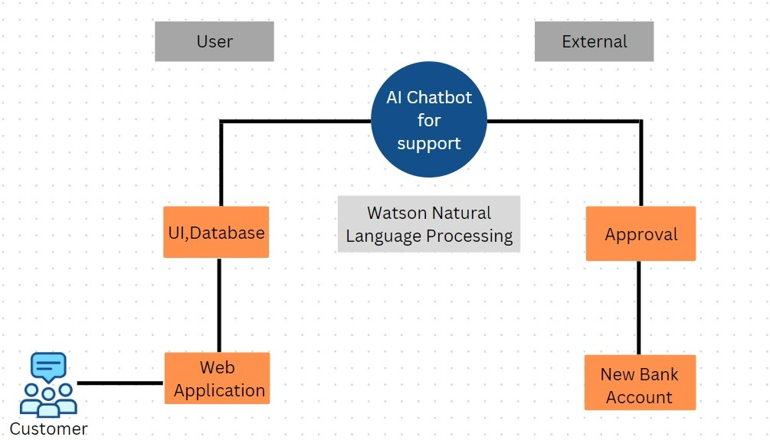

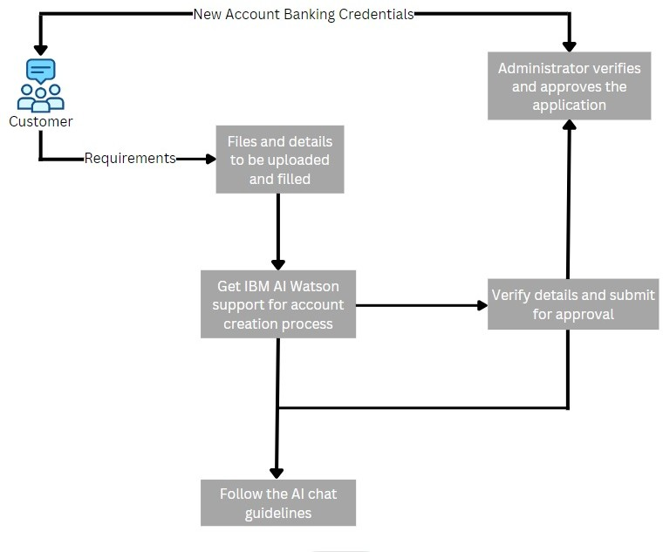

* 1. **SOLUTION AND TECHNICAL ARCHITECTURE**

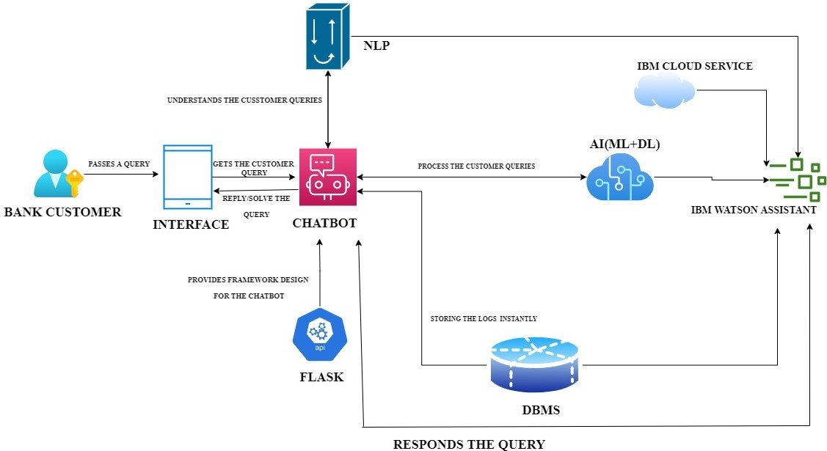

* 1. **User Stories**

|  |  |  |  |  |  |  |
| --- | --- | --- | --- | --- | --- | --- |
| **User Type** | **Functional**  **Requirement (Epic)** | **User Story Number** | **User Story / Task** | **Acceptance criteria** | **Priority** | **Release** |
| Customer (Mobile user) | Registration | USN-1 | As a user, I can register for the application by  entering my email, and password, and confirmingmy password. | I can access my account/dashboard | High | Sprint-1 |
|  |  | USN-2 | As a user, I will receive a confirmation emailonce I have registered for the application | I can receive a confirmationemail & click confirm | High | Sprint-1 |
|  |  | USN-3 | As a user, I can register for the application through Facebook | I can register & access the dashboard with Facebook Login | Low | Sprint-2 |
|  |  | USN-4 | As a user, I can register for the application through Gmail |  | Medium | Sprint-1 |
|  | Login | USN-5 | As a user, I can log into the application by entering my email & password |  | High | Sprint-1 |
|  | Dashboard | USN-6 | As a user, I can get the application completion  status and files to be required to create the account. | I can receive the completion status and create the account. | Low | Sprint-2 |
| Customer (Web user) | Registration | USN-1 | As a web user, I can go through many social  media websites, get the details and I can register for the application | I can access my application dashboard | High | Sprint-1 |
|  |  | USN-2 | As a user, I can get the details of the application through email. | I can receive a confirmationemail to link my application | Medium | Sprint-1 |
|  | Login | USN-3 | As a user, I can link my google account to register my application. | I can register my application. | High | Sprint-1 |
|  | Dashboard | USN-4 | As a user, I can manage and get a detailed view of the application | Any changes in the application come to my knowledge while checking  dashboard. | Low | Sprint-2 |
| Customer Care Executive | IBM Watson |  | AI-based IBM Watson provides full support for  the customer to guide and create new banking account | I can fill in the respective details in the respective field. | High | Sprint-1 |

|  |  |  |  |  |  |  |
| --- | --- | --- | --- | --- | --- | --- |
|  | Support |  | Customer support is also mentioned for  describing important issues faced by thecustomer. | I can get the detailed solution for the queries | Medium | Sprint-1 |
| Administrator | Verification |  | The administrator can completely verify thesubmitted application. | I can get verified for application. | High | Sprint-1 |
| **User Type** | **Functional Requirement (Epic)** | **User Story Number** | **User Story / Task** | **Acceptance criteria** | **Priority** | **Release** |
| Admin | Approval |  | After completion, new banking credentials are provided to the customers. | I can get my banking  credentials after approval of the application. | High | Sprint-1 |

# Project Planning & SCHEDULING

## SPRINT PLANNING & ESTIMATION

|  |  |  |  |  |  |  |
| --- | --- | --- | --- | --- | --- | --- |
| **Sprint** | **Functional Requirement (Epic)** | **User Story Number** | **User Story / Task** | **Story Points** | **Priority** | **Team Members** |
| Sprint-1 | Building of Assistant | USN-1 | Creation of a Banking Chatbot or Assistant using IBM Watson Assistant/ As a user, I can see a Banking Assistant. | 12 | High | Sananda,Priya |
| Sprint-1 |  | USN-2 | Understanding Customer’s Banking Related Queries and skills/ As a user, I can see a Chatbot with Banking skills. | 8 | Moderate | Santhya,Ni vetha |
| Sprint-2 | Modeling of Assistant | USN-3 | Building action and Adding responses to Account Creation/As a user, I can see a Chatbot that helps to create an account | 5 | High | Priya |
| Sprint-2 |  | USN-4 | Building action and Adding responses to Banking related queries/As a user, I can see a Chatbot that helps to solve the banking queries. | 5 | High | Sananda |
| Sprint-2 |  | USN-5 | Building action and Adding responses to Net Banking/As a user, I can see a Chatbot that helps to access Net Banking | 5 | High | Santhya |
| Sprint-2 |  | USN-6 | Building action and Adding responses to Loan Queries/As a user, I can see a Chatbot that helps in Loan-related Queries. | 5 | High | Nivetha |

|  |  |  |  |  |  |  |
| --- | --- | --- | --- | --- | --- | --- |
| Sprint-3 | Testing & Deployment Phase-I | USN-7 | Testing the chatbot performance with the trained banking functionalities or conversations/As a user, I can know the performance of the chatbot level | 10 | High | Priya, Sananda |

|  |  |  |  |  |  |  |
| --- | --- | --- | --- | --- | --- | --- |
| **Sprint** | **Functional Requirement (Epic)** | **User Story Number** | **User Story / Task** | **Story Points** | **Priority** | **Team Members** |
| Sprint-3 |  | USN-8 | Integration of Flask webpage with the chatbot assistant to provide a framework/As a user, I can see a webpage to access the chatbot. | 10 | High | Santhya, Nivetha |
| Sprint-4 | Deployment Phase-II & Model Improvement | USN-9 | Deployment of AI-based chatbot for the banking Industry or Running the Chatbot service/As a user, I can see and use a 24*7 banking chatbot. | 15 | High | Priya, Santhya, Nivetha, Sananda |
| Sprint-4 |  | USN-10 | Improving the model efficiency whenever needed/As a user, I can see the newly updatedchatbot in Future days. | 5 | Moderate | Priya, Santhya, Nivetha, Sananda |

* 1. **SPRINT DELIVERY SCHEDULE**

|  |  |  |  |  |  |  |
| --- | --- | --- | --- | --- | --- | --- |
| **Sprint** | **Total Story Points** | **Duration** | **Sprint Start Date** | **Sprint End Date (Planned)** | **Story Points Completed (as on Planned End Date)** | **Sprint Release Date (Actual)** |
| Sprint-1 | 20 | 5 Days | 31 Oct 2022 | 5 Nov 2022 | 20 | 5 Oct 2022 |
| Sprint-2 | 20 | 5 Days | 5 Nov 2022 | 9 Nov 2022 | 20 | 9 Nov 2022 |
| Sprint-3 | 20 | 5 Days | 10 Nov 2022 | 14 Nov 2022 | 20 | 14 Nov 2022 |
| Sprint-4 | 20 | 5 Days | 15 Nov 2022 | 19 Nov 2022 | 20 | 19 Nov 2022 |

# CODING & SOLUTIONING

## FEATURE 1

**CREATING CHATBOT & INTEGRATE WITH FLASK WEB PAGE**

**Importing Libraries**



Importing the flask module into the project is mandatory. An object of the Flask class is our WSGI application. The Flask constructor takes the name of the current module ( name ).

**Creating our flask application and loading**

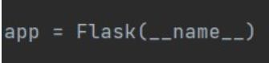

**Routing to the Html Page**

Here, the declared constructor is used to route to the HTML page created earlier.

The ‘/’ route is bound with the bot function. Hence, when the home page of a web server isopened in the browser, the HTML page will be rendered.

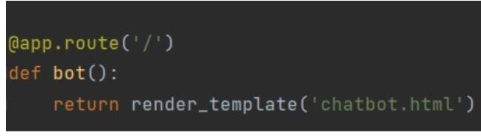

## Main Function

This is used to run the application in localhost.

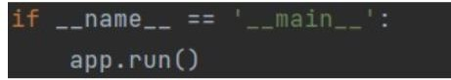

## FEATURE 2

**AUTO-GENERATED SOURCE CODE IS COPIED FROM IBM WATSON’SASSISTANT AND PLACED INSIDE THE BODY TAG.**

<script> window.watsonAssistantChatOptions = {

integrationID: "57973caf-2eea-40b2-8350-2be5de578e3d", // The ID of this integration. region: "us-south", // The region your integration is hosted in.

serviceInstanceID: "f10f0998-3d51-4d9d-973f-1950c0c56ed0", // The ID of your service instance. onLoad: function(instance) { instance.render(); }

};

setTimeout(function(){

const t=document.createElement('script');

t.src="https://web-chat.global.assistant.watson.appdomain.cloud/versions/" + (window.watsonAssistantChatOptions.clientVersion || 'latest') + "/WatsonAssistantChatEntry.js";

document.head.appendChild(t);

});

</script>

Through this code, the created CHATBOT with the functionalities,

* Savings Account Action
* Current Account Action
* Loan Account Action
* Net Banking Action
* General Query Action can be achieved.

# Testing

## TEST CASES

* + - Verify the user is able to open and view the chatbot UI
    - Verify whether the user is able to interact with the chatbot or not
    - Verify chatbot is able to respond to user queries
    - Verify chatbot is able to provide options for users to choose various choices

## USER ACCEPTANCE TESTING

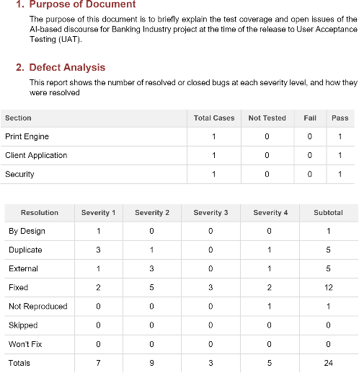

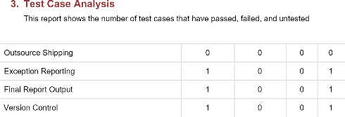

1. RESULTS

## PERFORMACE METRICS

Model Performance Testing

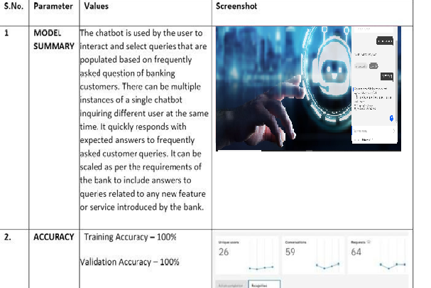

# ADVANTAGES AND DISADVANTAGES

## Advantages:

Artificial intelligence may assist customers in many ways. The most common use scenario for chatbots in bank customer service is the automatization of repetitive mundane tasks. Such tasks need fast and simple solutions that require self-learning, but at the same time, do not imply creativity. They include, among other activities:

* + - greeting customers
    - obtaining information regarding their problem

Providing the requested information to clients

accepting a payment from a user

* + - and many other simple tasks.

Implementing a Chatbot with conversational AI is a great way to automate customer service and improve the service provided by agents, leading to cost optimization in the medium term.

Bots can respond to customer inquiries around the clock without costing you extra. With 24/7 chat capabilities, your bot can answer customer questions instantly, without requiring them to call your service team between working hours.

## Disadvantages

When you collect your customer data, it’s your responsibility to keep it secure. The data needs to be transmitted from the chatbot to your CRM in a secure manner.

When a customer’s question isn’t clear or is too specific, a bot may have a hard time helping, which is one of the biggest disadvantages of chatbots. Chatbots are programmed to answer general questions with answers that can be found in its database, so if a customer asks something outside of this narrow list of answerable questions, they will likely confuse the bot and will either be taken around in circles as the bot tries to understand the question being asked (often to no avail), or simply be left without an answer. In either case, this isn’t a great customer experience and can negatively impact your company’s image.

Chatbots are poor at making decisions, unlike human beings. Certain chatbots are poor in memory and do not store past conversations.

Certain chatbots have limited availability of data and require some time for their self-update. This process leads to slower response times and expensive solutions.

# CONCLUSION

The goal is to implement Conversational Banking solutions in successful customer service to provide clients with a better experience. AI-powered Conversational chatbot reduces costs, radically boosts client satisfaction and loyalty, and eliminates human mistakes caused by an emotional state of mind. Setting up the process could be challenging, so it is crucial to choose the right technology partner.

A well-designed chatbot provides specific user input at each point, learns from customer feedback and follow-up queries, and improvises, thus enhancing the user experience it performs mundane tasks in a quick way.

# FUTURE SCOPE

Businesses that favor one-on-one or telephone talks are now obsolete as the world of technology expands. Customers are now demanding quicker forms of communication via messenger programs. The only way to improve conversion rates in the market now is to improve customer experience. Experiences that make the lives of customers and employees more accessible, safer, and of course more productive!

Chatbots will be able to have seamless and realistic conversations with customers and help enterprises improve their customer engagements. These chatbots are predicted to be able to handle more than 30% of customer interactions, which amounts to a whopping multi-billion-dollar worth of savings for businesses.

1. **APPENDIX**

**SOURCE CODE**

from flask import Flask, render_template app = Flask( name )

@app.route('/')

def hello_world(): # put application's code here return render_template("chatbot.html")

if name == ' main ': app.run()

chatbot.html

<!DOCTYPE html>

<html lang="en">

<head>

<meta charset="UTF-8">

<title>Output</title>

<link rel="stylesheet" href="https://maxcdn.bootstrapcdn.com/bootstrap/3.4.1/css/bootstrap.min.css ">

<style>

body

{

background-image: url("https[://www.santanderassetmanagement.es/wp-](http://www.santanderassetmanagement.es/wp-) content/uploads/2018/07/chatbots.jpg");

background-size: cover;

}

</style>

</head>

<body>

<script>

***window***.watsonAssistantChatOptions = {

integrationID: "45c211e5-94a4-493f-b22d-f2114f9c6dc2", // The ID of this integration.

region: "us-south", // The region your integration is hosted in.

serviceInstanceID: "9e4ca927-079e-4257-b1f5-9778ef4f3506", // The ID of your service instance.

onLoad: function(instance) { instance.render(); }

};

setTimeout(function(){

const t=***document***.createElement('script');

t.src="https://web- chat.global.assistant.watson.appdomain.cloud/versions/" + (***window***.watsonAssistantChatOptions.clientVersion || 'latest') + "/WatsonAssistantChatEntry.js";

***document***.head.appendChild(t);

});

</script>

</body>

</html>

## GITHUB LINK:

<https://github.com/IBM-EPBL/IBM-Project-24336-1659941668>

## PROJECT DEMO LINK:

[https://drive.google.com/drive/folders/1eugeLPayMTjcbjDVulgZaC7mSIUsuf7J](https://drive.google.com/drive/folders/1eugeLPayMTjcbjDVulgZaC7mSIUsuf7J?usp=share_link)

[?usp=share_link](https://drive.google.com/drive/folders/1eugeLPayMTjcbjDVulgZaC7mSIUsuf7J?usp=share_link)